DAY 14  
MINIMUM DEPTH OF BINARY TREE  
  
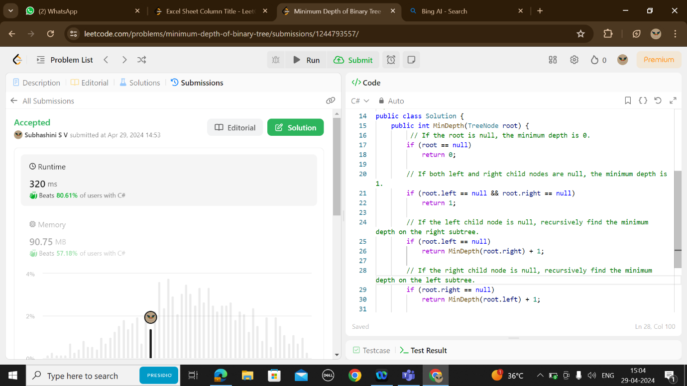

EXCEL SHEET NUMBER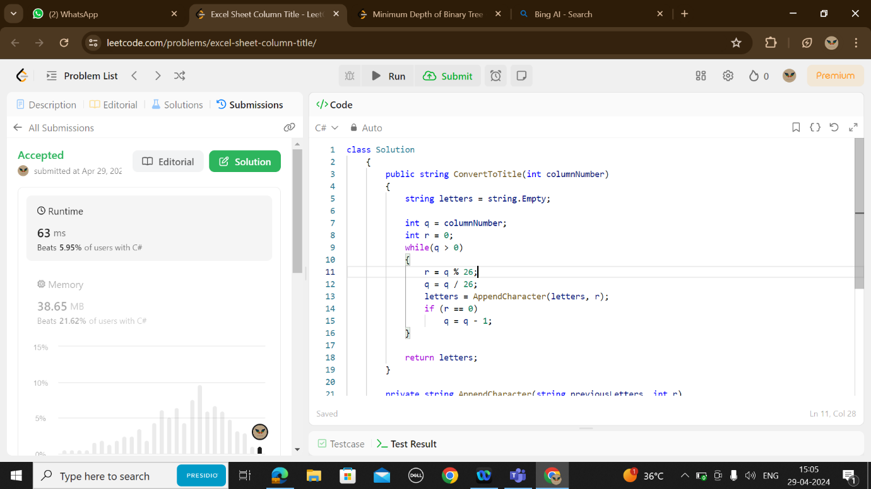

CIRCULAR LINKED LIST  
